# MINI PROJECT (2020-21)

**OMNI MEET**

**FINAL REPORT**



**Institute of Engineering & Technology**

**Submitted by-**

**Vishes Keshari (181500813)**

**Pulkit Ranjan (181500519)**

**Gaurav Kumar (181500233)**

**Aditya Kumar Das (181500041)**

***Supervised By:***

**Mrs. Harvinder Kaur**

Technical Trainer

# Department of Computer Engineering & Applications

|  |
| --- |
| **TABLE OF CONTENTS** |
| **Certificate 4**  **Synopsis 9**  **Acknowledgement 11**  **Abstract… 12** |
| **1. Introduction….…………………………………………………………….** |
| 1.1 Overview 13 |
| 1.2 Motivation 14 |
| 1.3 Problem Statement 15 |
| 1.4 Objective… 15 |
| **2. Software Requirement Analysis…………………………………………..** |
| 2.1 System Analysis 16 |
| * 1. Users 17 |
| 2.3Methodology 17   * 1. Dependencies /External Systems 18   2. Use-case Diagram 20 |
| 1. **Implementation details 21** 2. **Contribution Summary 22** |

|  |
| --- |
| 1. **Project Work 23** 2. **Future Scope… 51** |
| **Reference 51** |

**Certificate**

This is to certify that Aditya Kumar Das, Gaurav Kumar, Pulkit Ranjan and Vishes Keshari students of B Tech (CSE) 3rd year has successfully completed the **MINI PROJECT** named **OMNI MEET** on Web Development under the Guidance of **Ms. Harvinder Kaur** During 2020-21.

Signature:

**Ms. Harvinder Kaur**

(Mentor)

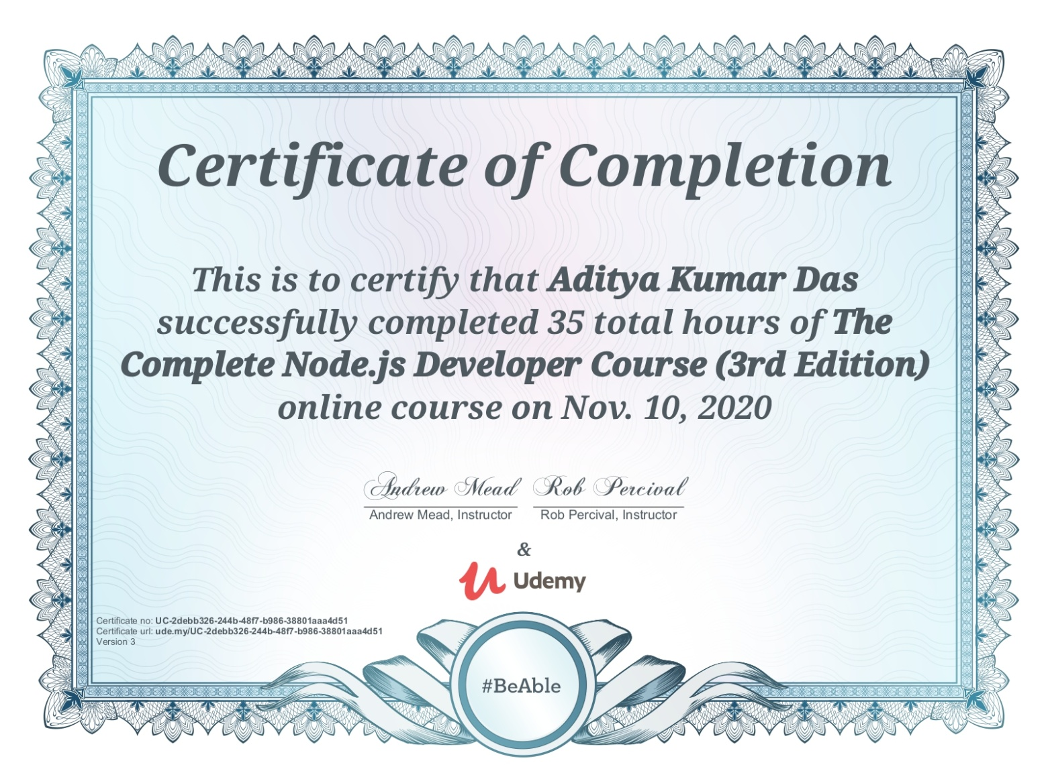

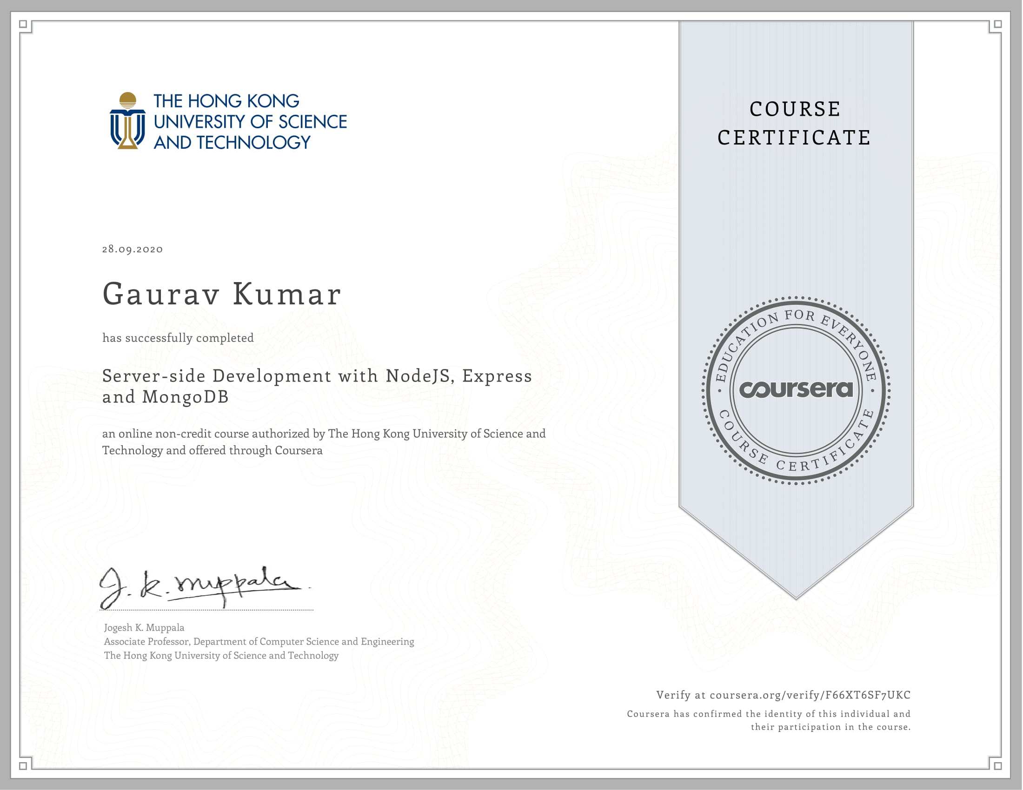

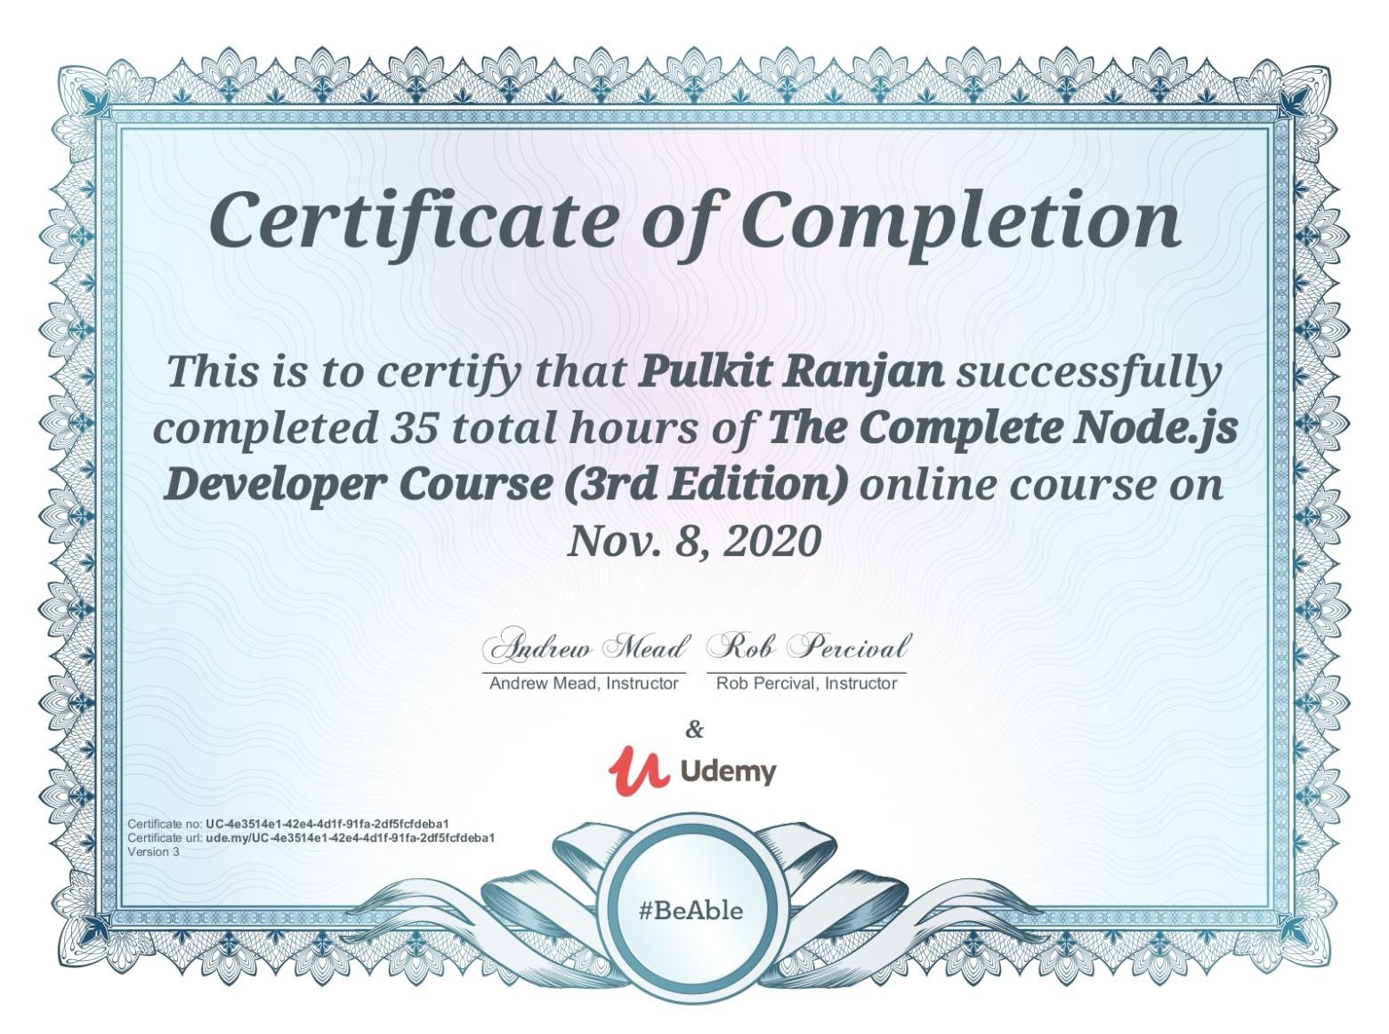

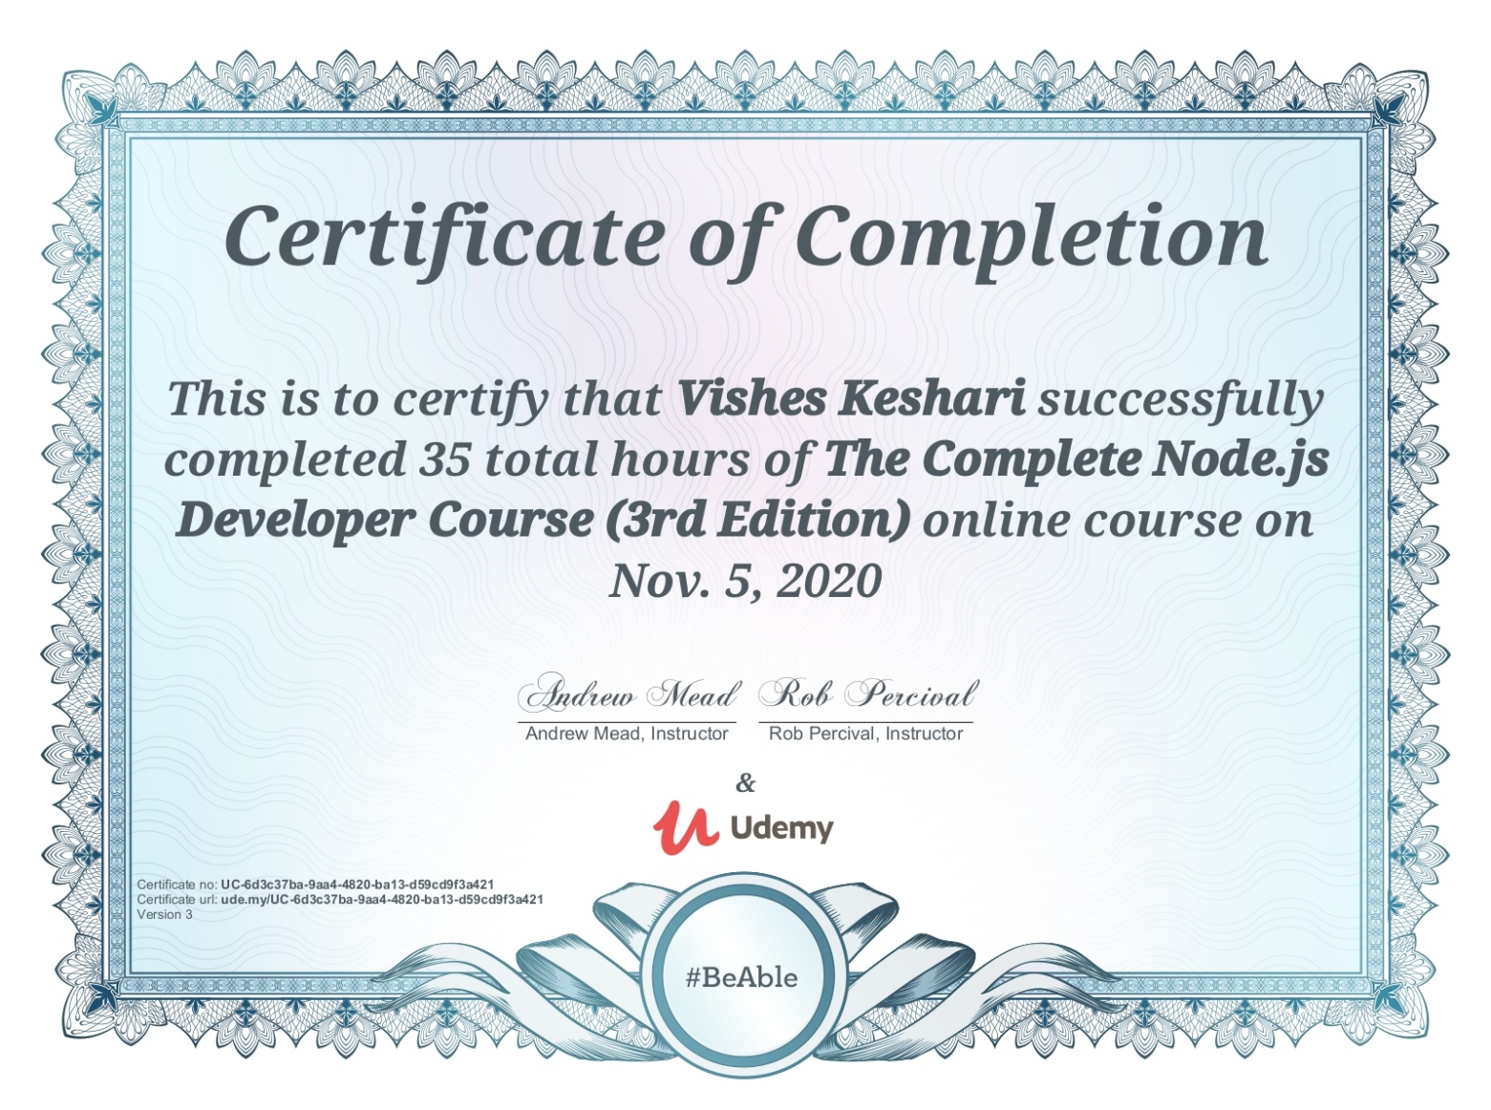



**MINI PROJECT Synopsis**

**B.Tech. (CSE)-Batch 2018-2022**

Project Information:

|  |  |
| --- | --- |
| Title of Project/Training/Task | Omni Meet |
| Role & Responsibility | Aditya Kumar Das: Creating Room  Gaurav Kumar: Video Streaming  Vishes Keshari: Building and Styling  Pulkit Ranjan: Creating Chat Room |
| Technical Details | Hardware Requirements:   * 2 GB RAM * 20 GB OF HARDDISK * Processor i3 (7th Gen) * Internet connection   Software Requirements:   * Technology Implemented: Web Development and Web-Sockets * Language Used: HTML, CSS, JavaScript, Node.js * Web Browser: Google Chrome (Version: 84.0.4147.135 or above*)* * Code editor: Windows Visual Studio *(*Version:16.0 or above*)* |

**Summary of the Work:**

During the completion of this project Omni Meet we learnt about HTML5, CSS, Node.js, and some basic JavaScript.

1. **Aditya Kumar Das: -** Creating Room

**.** Initializing NodeJS Project.

**.** Initializing first view using HTML.

**.** Creating Room ID.

1. **Vishes Keshari**:**-** Building and Styling

**.** Placement of buttons and adding functionality to them.

**.** Adding color, effects and designing features to different section of web app.

1. **Gaurav Kumar: -** Video

**.** Adding the ability to view our own video.

**.** Adding the ability to allow others to stream their video.

1. **Pulkit Ranjan: -** Chat Room.

**.** Creating a medium for messages to pass from sender to server and then from server to receiver.

**.** Adding the feature of scrolling the messages up and down.

.

**Acknowledgment**

We have taken efforts in this project. However, it would not have been possible without the kind support and help of many Teachers. I would like to extend my sincere thanks to all of them.

We are highly indebted to Ms. Harvinder Kaur for her guidance and constant supervision as well as for providing necessary information regarding the project & also for his support in completing the project.

We would like to express my gratitude towards our parents & member of GLA University for their kind co-operation and encouragement which help us in completion of this project.

## Abstract

The report presents the three tasks that is being in continuation during college time at GLA University which are listed below:

1. Understanding of the Problem objective & implication.
2. Understanding of the data & building of the model.
3. Evaluation of the model.

All these tasks have been completed successfully and results were according to expectations. All the tasks were need very systematic approach, starting from the collection of the data to the implementation of the solution and till evaluation of the System. The most challenging task was the domain knowledge, to understand the language. It is one of the major areas and really need very fundamental and conceptual knowledge of HTML, CSS, JavaScript, and Node.JS.

# Introduction

* + Overview

All the functional/non-functional requirements, corresponding Use Case Diagrams have been organized in this report. Along with these designs, this report also contains the essential data of this project.

* The Our project is an example of a client server application. It is a real-time and multi-platform application and can be used by many users. It provides video telephony and online chat service through a peer to peer service platform and it uses tele-conferencing and tele-commuting.
  + **Motivation**

In current scenario, Major advancements in technology have drastically changed how and where we conduct business with more people working remotely, the rise of instant, on-demand communications and the globalization of businesses. For modern and innovative businesses to grow and globalize, building and maintaining quality relationships with partners, suppliers, internal teams, investors and customers is essential. Video conferencing boosts productivity, saves time, reduces travel expenses, and overall promotes collaboration. The advantage of video conferencing is the ability to facilitate all of those benefits without requiring constant travel for face-to-face communication.

Video conferencing describes online meetings that take place over the internet to connect video conferencing systems in meeting rooms with personal devices such as laptops or mobile devices with embedded webcams. Utilizing a simple, unified video conferencing solution with support for screen sharing empowers your global teams to be more connected, productive and engaged.

* + **Problem Statement**

This project is to create an application with a server and client that enables video conferencing and texting in Realtime.

* + **Objective**
* This project is a real-time web application with very simple UI.
* Users can video chat or send and receive text in Realtime.
* To generate an IP Address for multiple users to connect to the same chat room.

**System and Requirement Analysis**

* 1. **System Analysis**

System analysis is a process of collecting and interpreting facts, identifying the problems, and decomposition of the system into its components.

It is a process of studying a system in order to define its goals or purposes and to discover operations and procedures for accomplishing them most efficiently.

For modern and innovative businesses to grow and globalize, building and maintaining quality relationships with partners, suppliers, internal teams, investors and customers is essential. Video conferencing boosts productivity, saves time, reduces travel expenses, and overall promotes collaboration. The advantage of video conferencing is the ability to facilitate all of those benefits without requiring constant travel for face-to-face communication

### **Users**

The User of the web application would be the people who want to do Video Conference along with Real-time Chatting.

### **Methodology**

- First, we will work on making design for our website using pencil wireframe.

- Next, we will Initialize our NodeJS Project.

- Then we will Initialize our first view Using HTML.

- After initializing first view we will create a Room ID.

- Then we will add the ability to view our own video.

- Soon after above we will add ability to allow others to stream their video.

- Then we will add Styling Using CSS.

- After adding Styling, we will add the ability to create messages.

- Followed by adding mute button.

- Then at last we will add Stop Video Button too.

### **Dependencies/External Systems**

**User Interfaces:**

Once you are in your Zoom Meeting session, there are options that allow you to:

* + Enable/Disable Video Streaming.
  + Enable/Disable Audio Streaming.
  + Send Text message in a Group.

**Hardware Interfaces:**

The application will require a system with an active internet connection and permission to access the camera and microphone.

**HARDWARE REQUIREMENT (MINIMUM)**

* 2 GB RAM
* 20 GB OF HARDDISK
* Processor i3 (7th Gen)
* Internet

**SOFTWARE REQUIREMENT-**

* + Technology Implemented: Web Development and Web-Sockets
  + Language Used: HTML, CSS, JavaScript, Node.js
  + Web Browser: Google Chrome (Version:84.0.4147.135or above*)*
  + Code editor: Windows Visual Studio *(*Version: *16.0* or above*)*

**USE DIAGRAM**

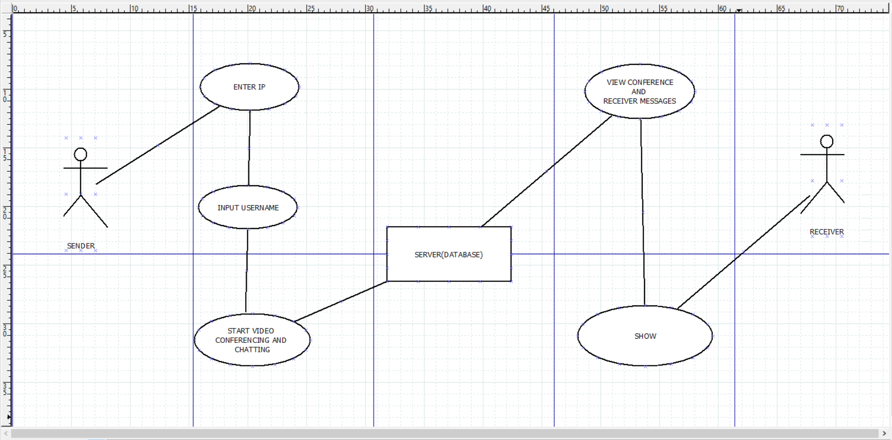

**Implementation Details**

- First, we worked on making design for our website using pencil wireframe.

- Next, we Initialized our NodeJS Project.

- Then we Initialized our first view Using HTML.

- After initializing first view we created a Room ID.

- Then we added the ability to view our own video.

- Soon after above we added ability to allow others to stream their video.

- Then we added Styling Using CSS.

- After adding Styling, we added the ability to create messages.

- Followed by adding mute button.

- Then at last we added Stop Video Button too.

### **Contribution Summary**

OUR TEAM:

1. **Aditya Kumar Das: -** Creating Room

**.** Initializing NodeJS Project.

**.** Initializing first view using HTML.

**.** Creating Room ID.

1. **Vishes Keshari**: **-** Building and Styling

**.** Placement of buttons and adding functionality to them.

**.** Adding color, effects and designing features to different section of web app.

1. **Gaurav Kumar: -** Video

**.** Adding the ability to view our own video.

**.** Adding the ability to allow others to stream their video.

1. **Pulkit Ranjan: -** Chat Room.

**.** Creating a medium for messages to pass from sender to server and then from server to receiver.

**.** Adding the feature of scrolling the messages up and down.

**Project Work:**

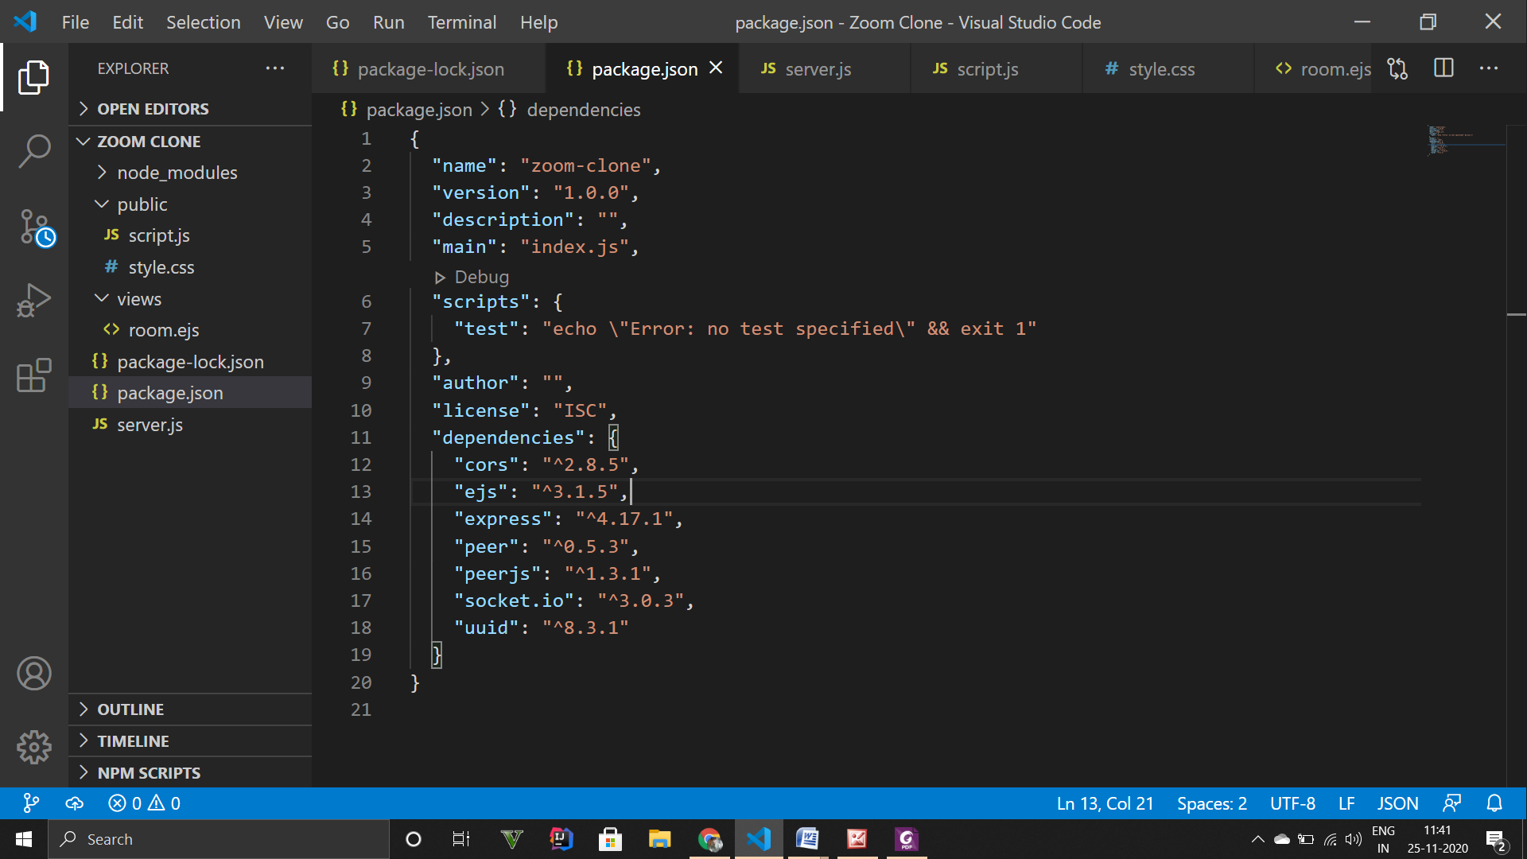

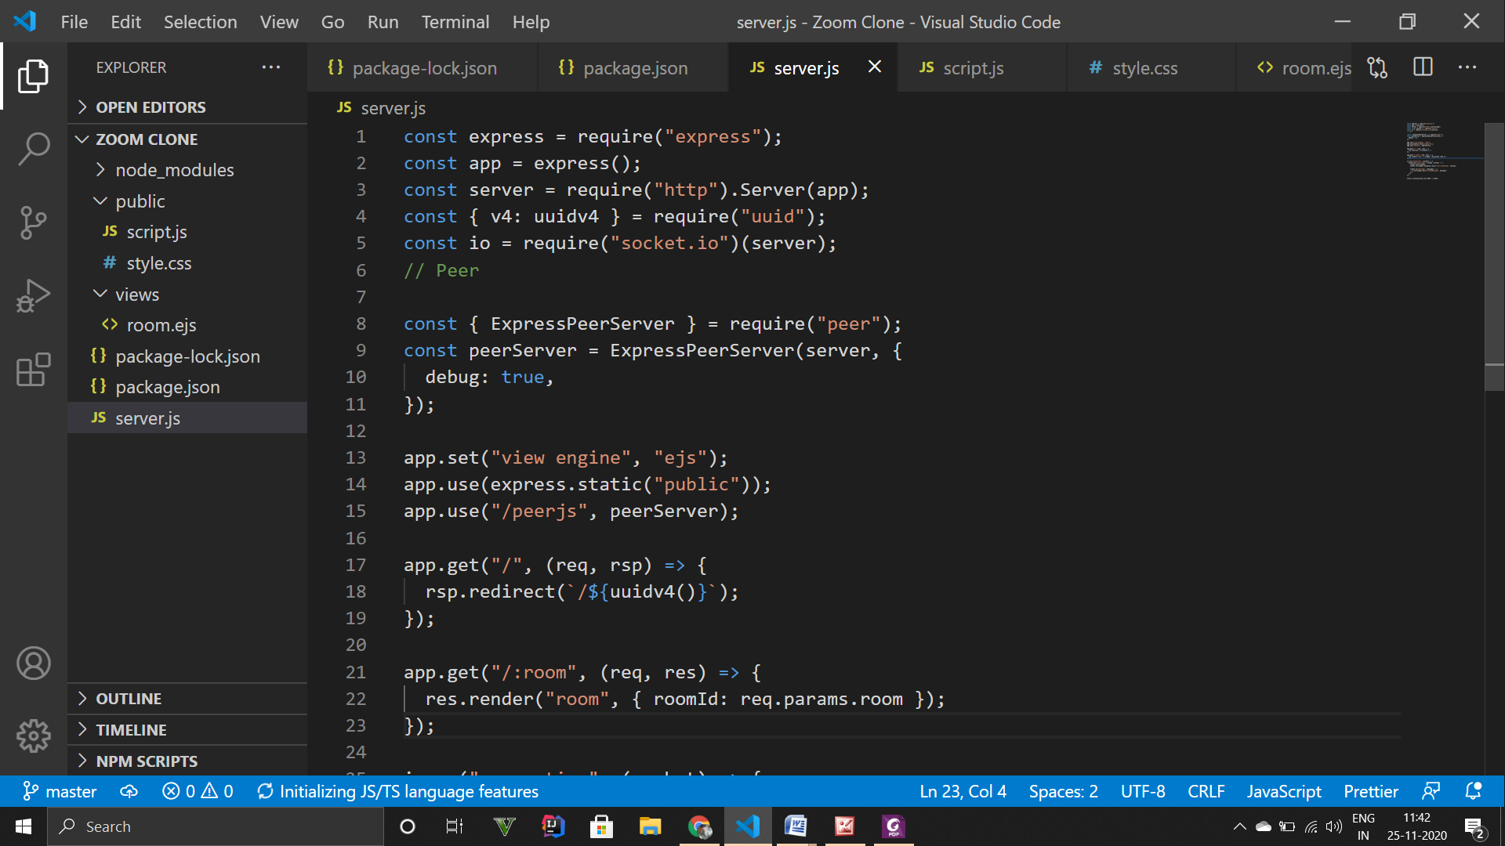

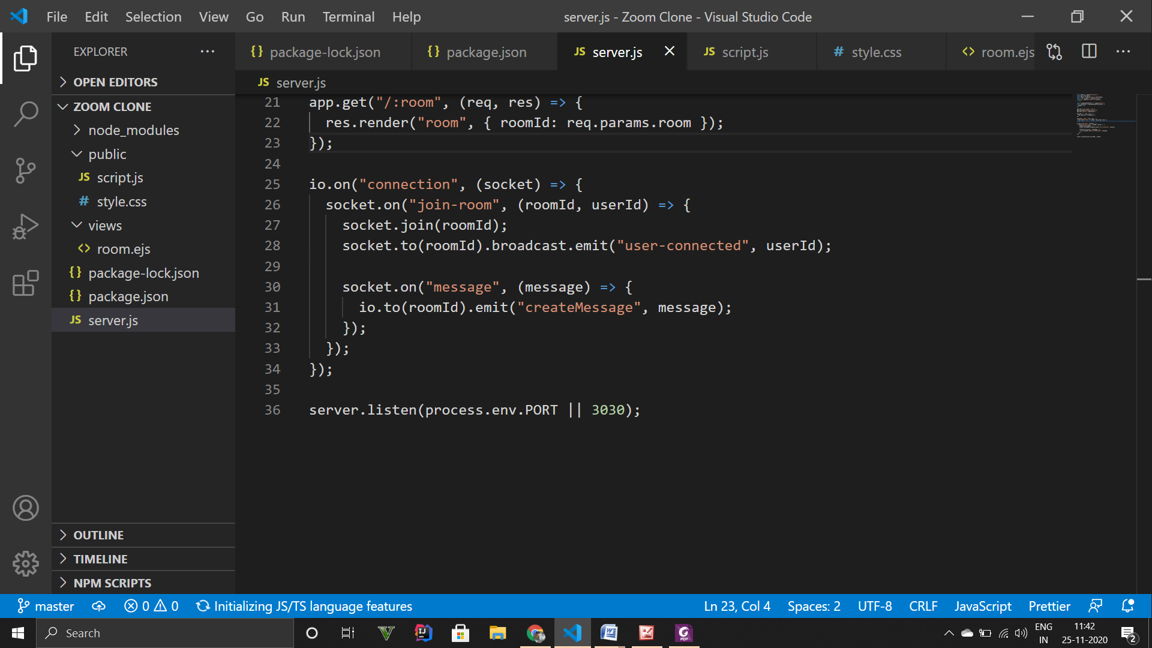

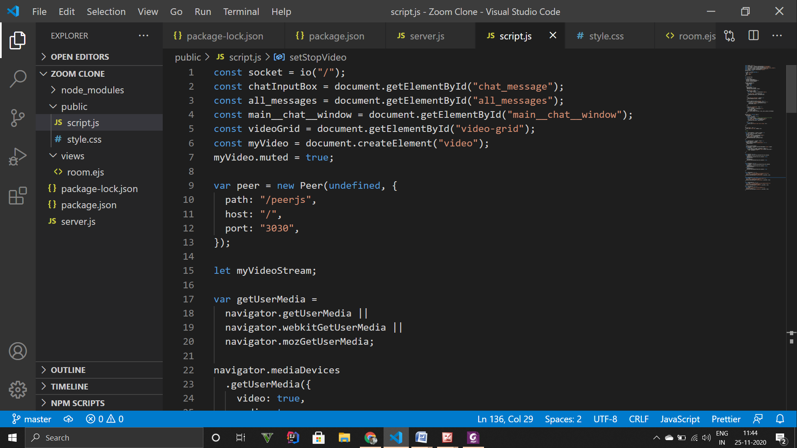

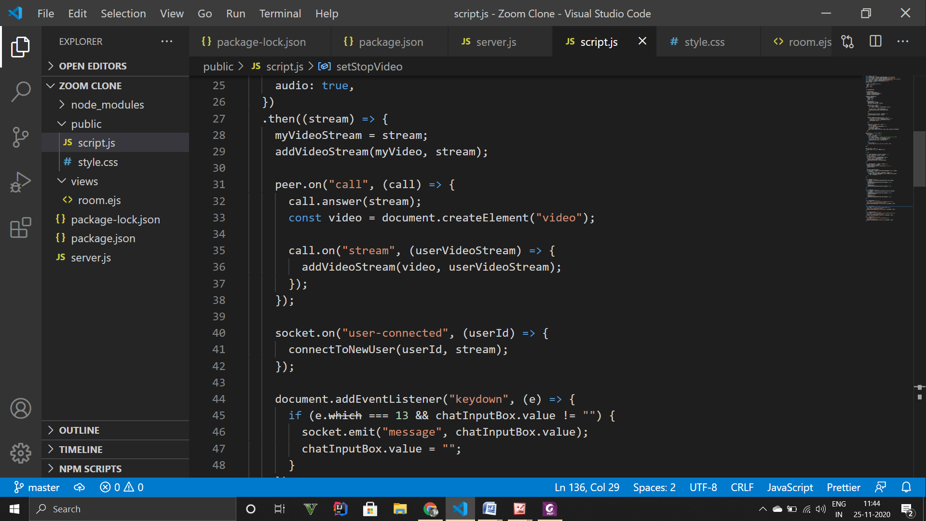

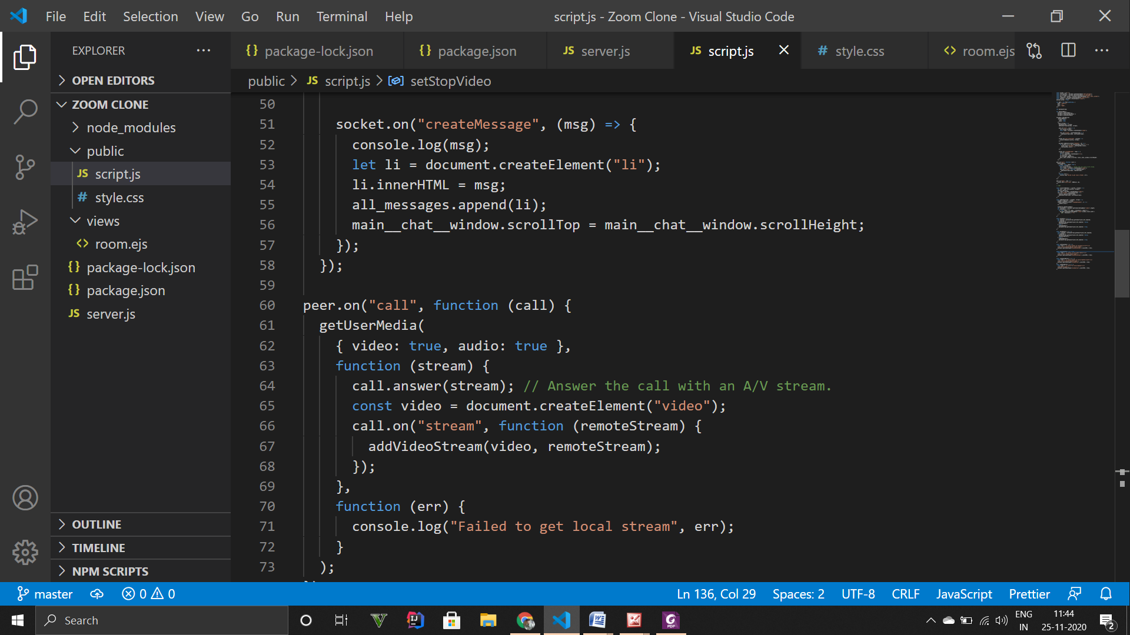

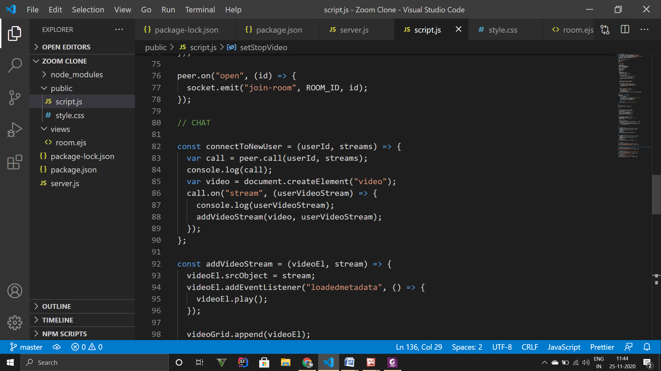

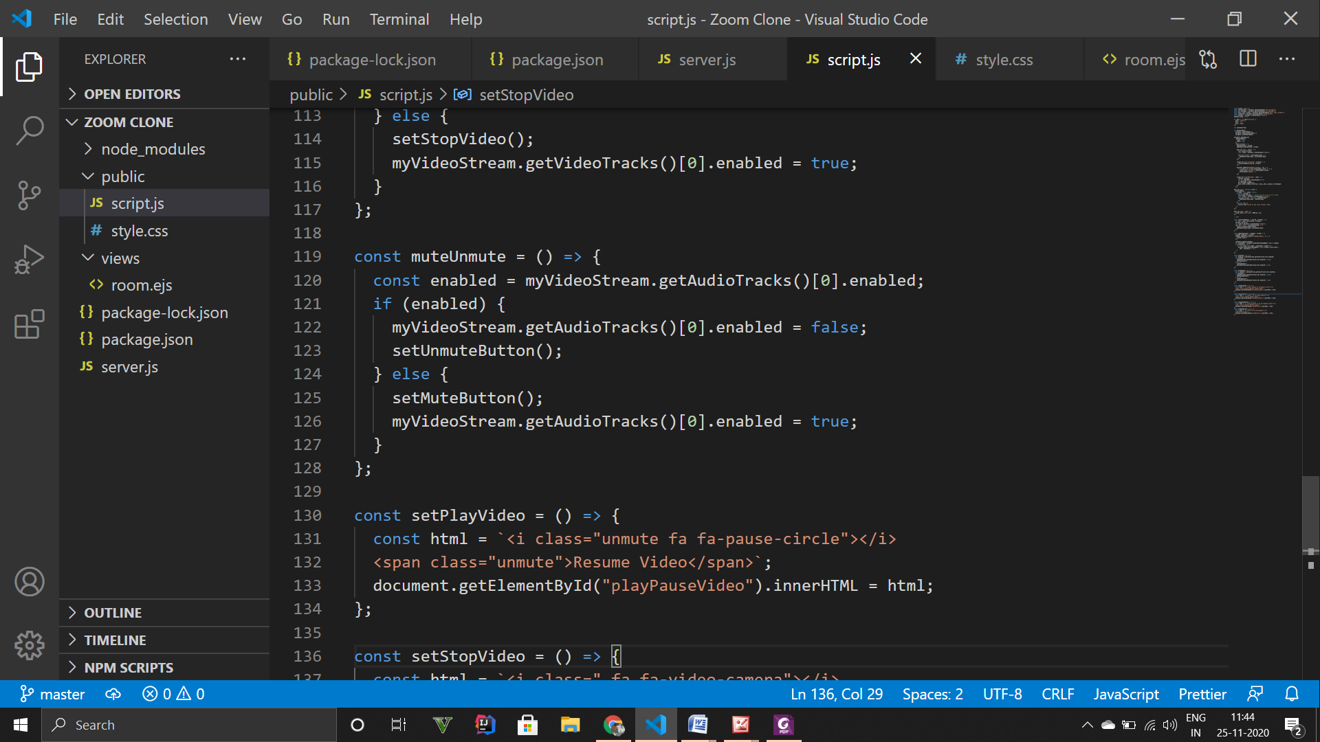

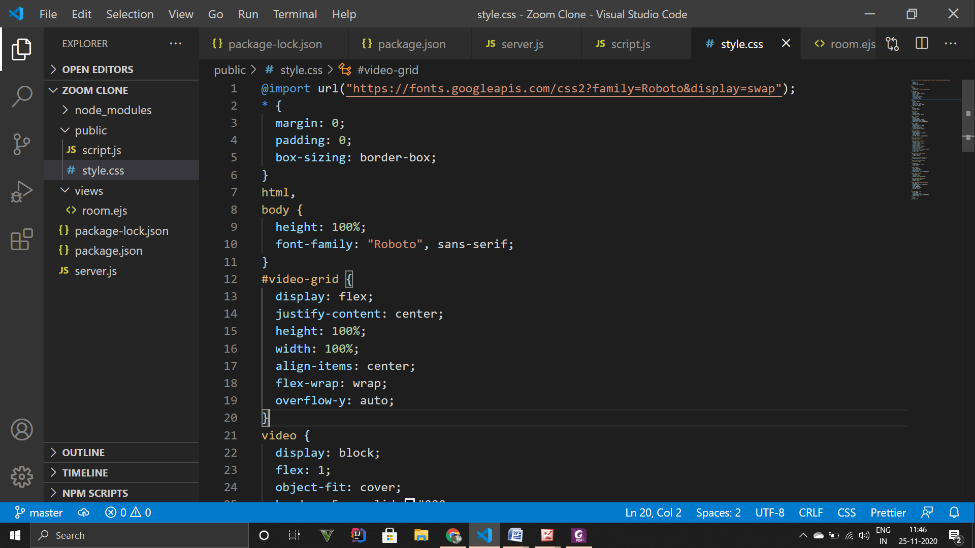

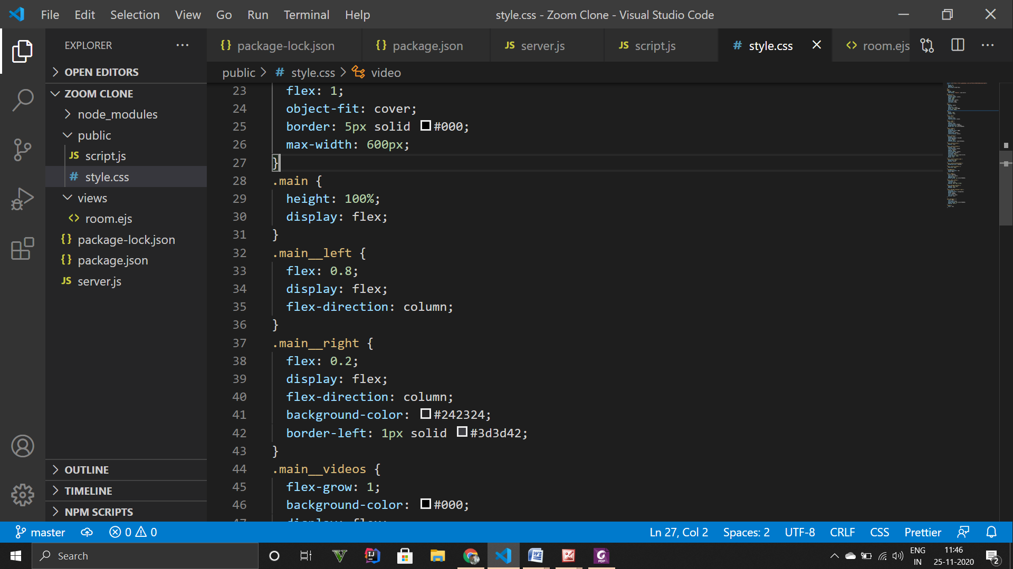

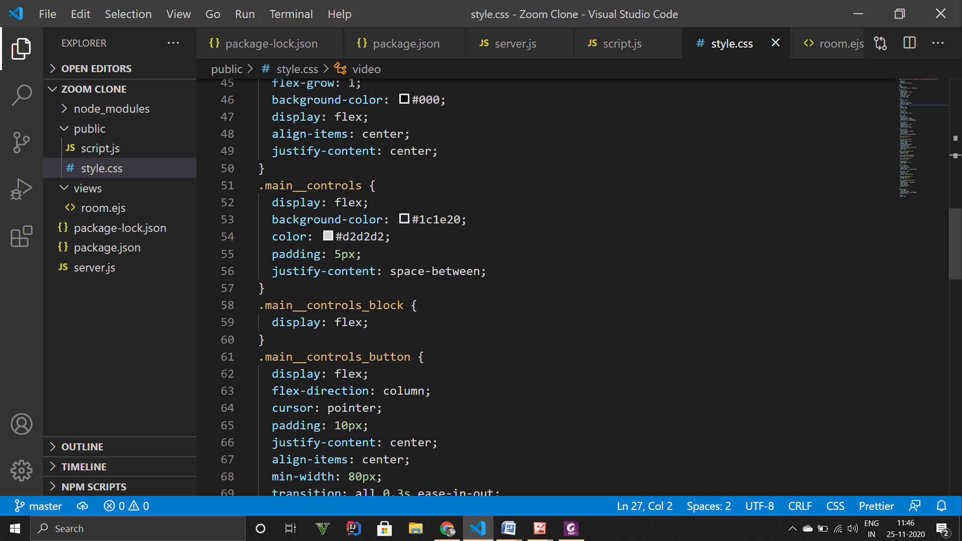

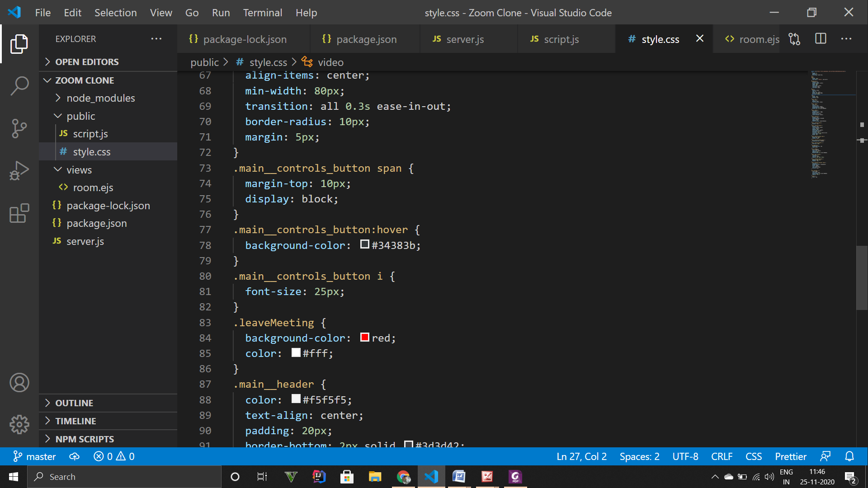

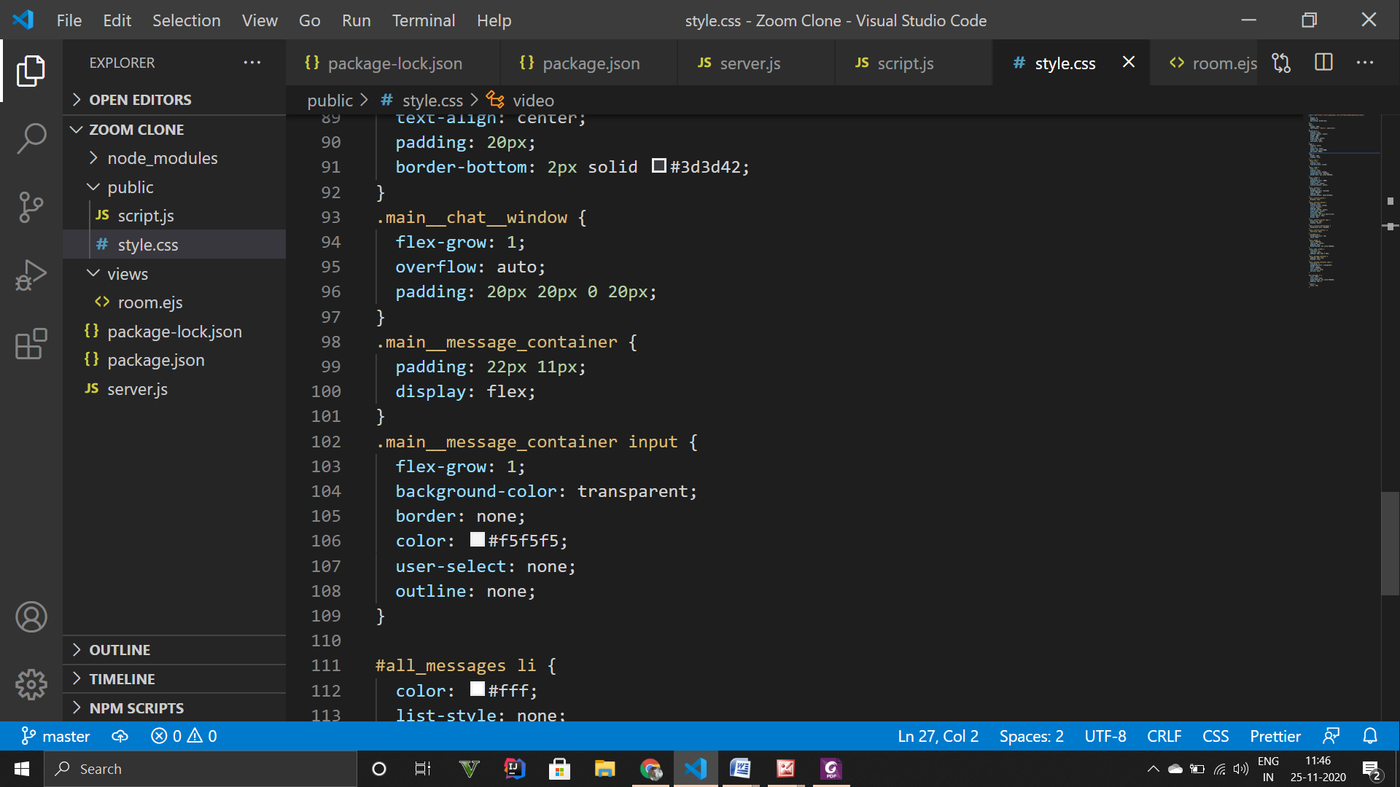

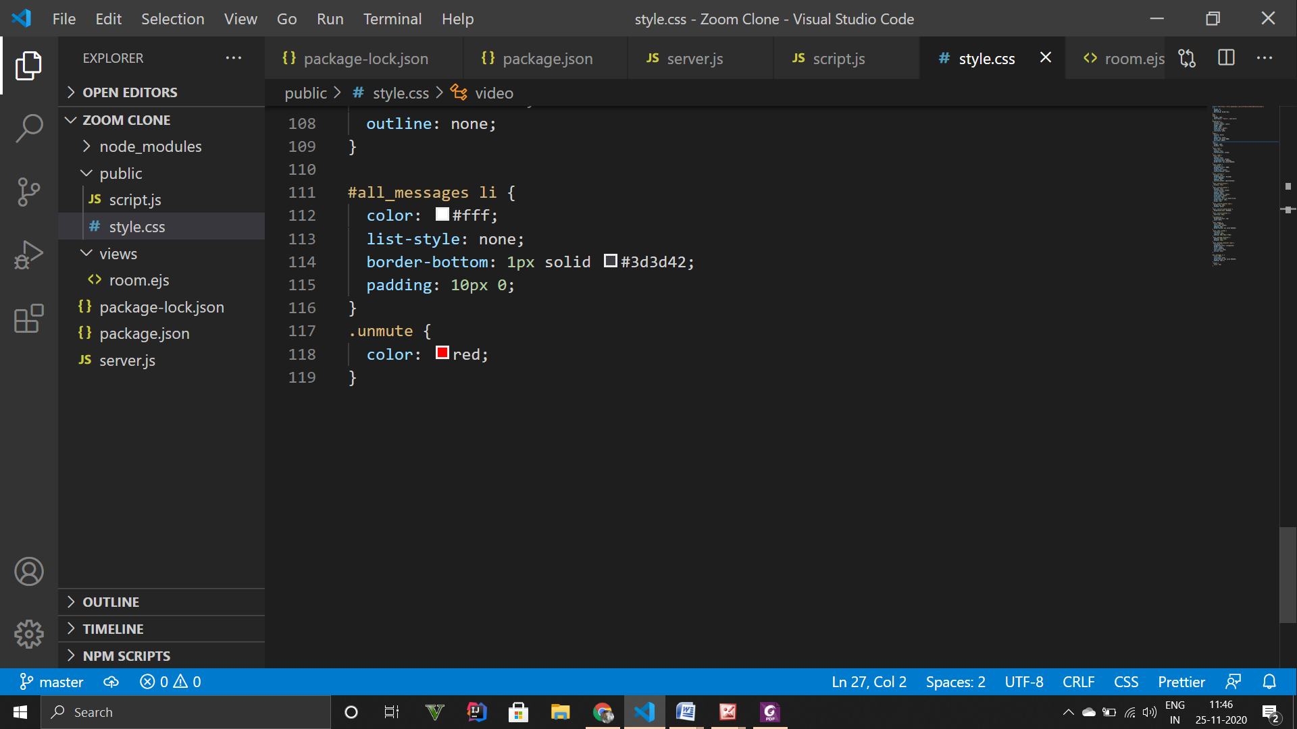

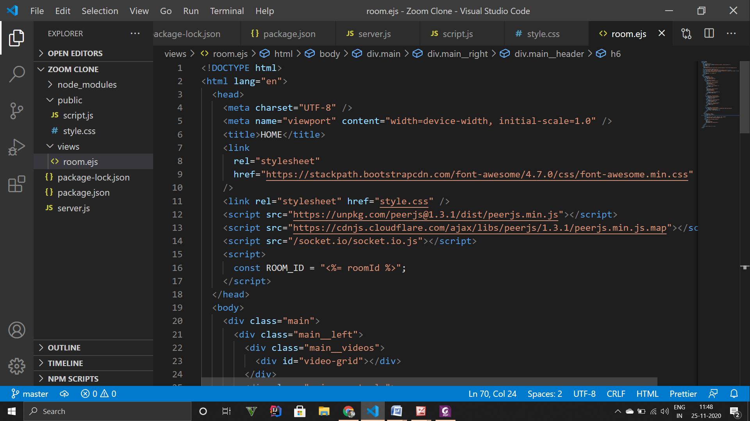

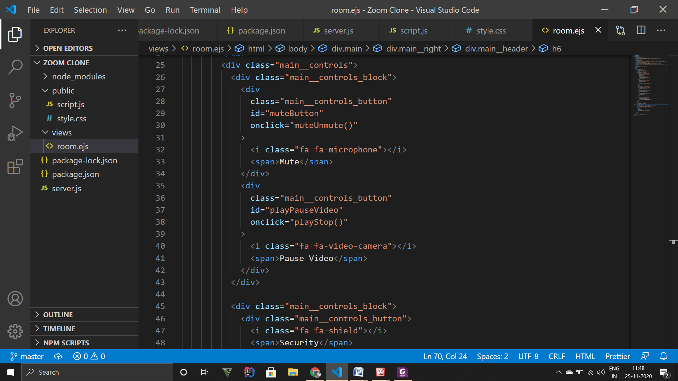

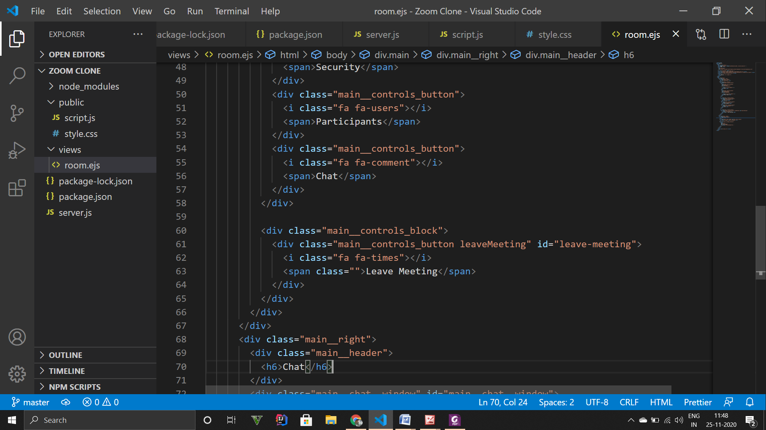

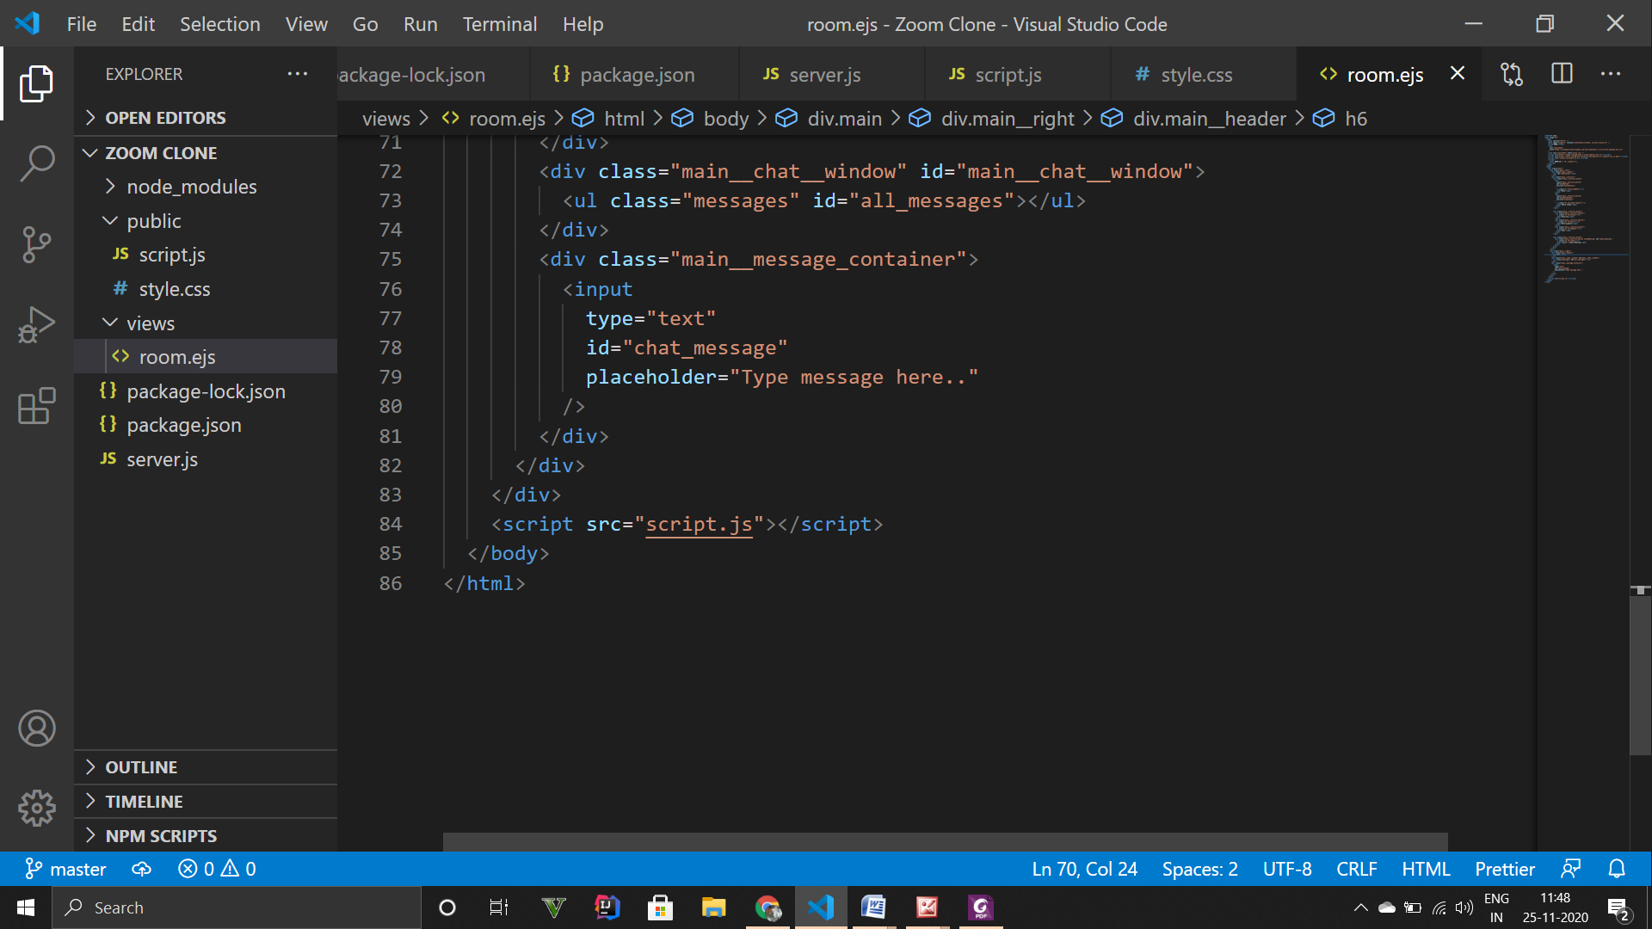

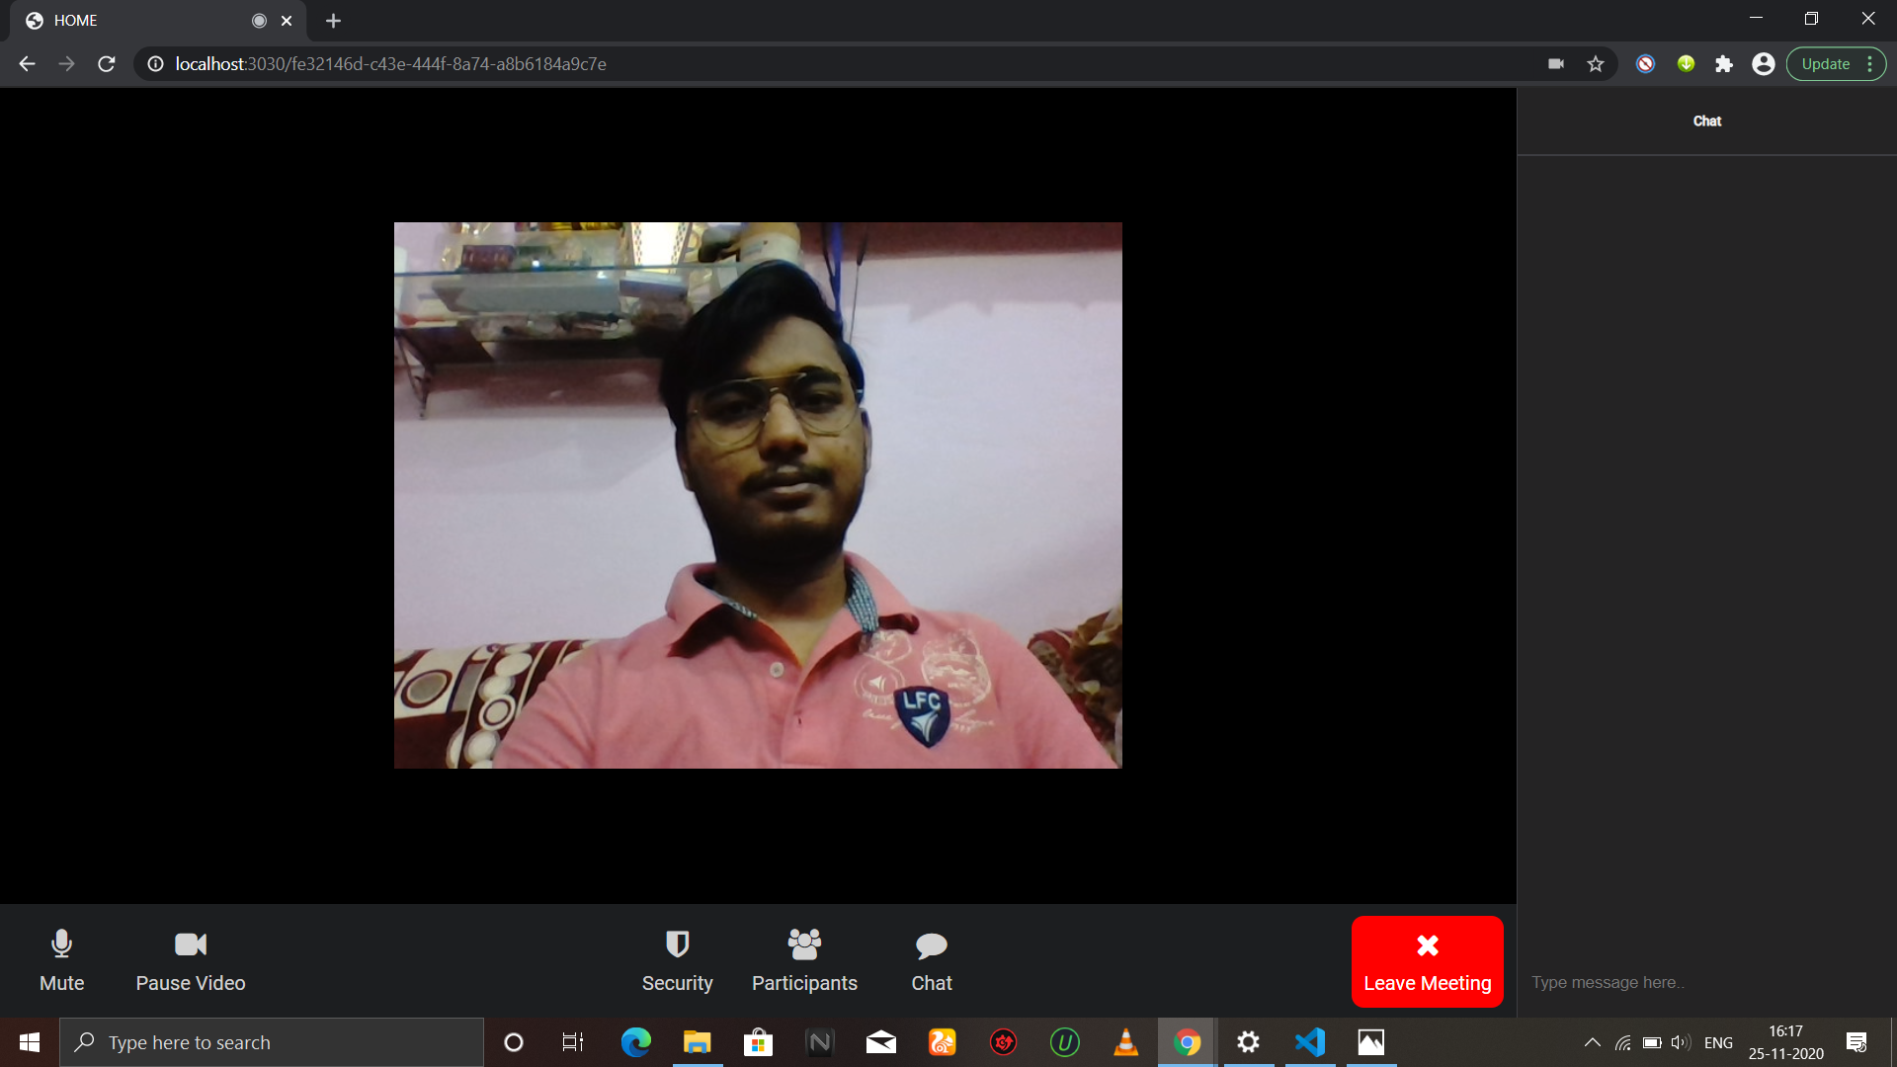

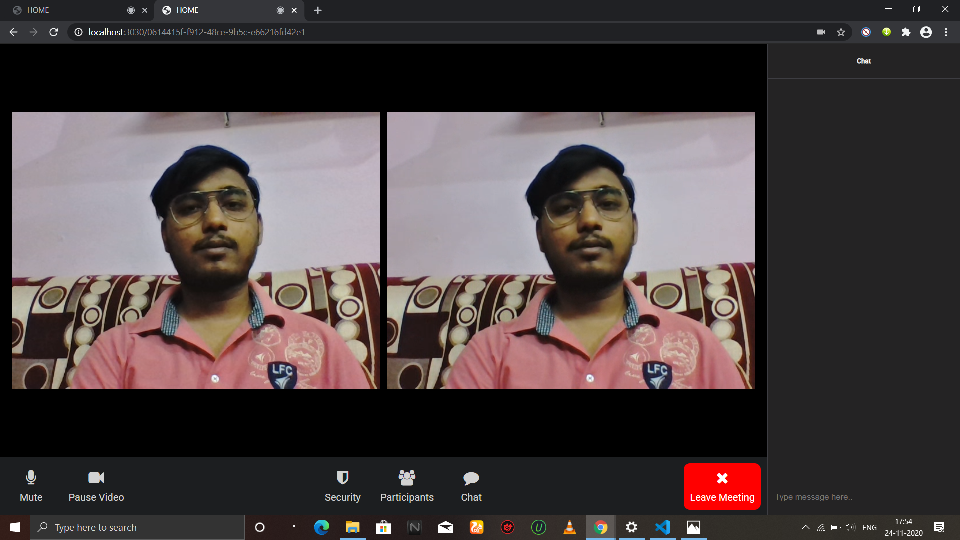

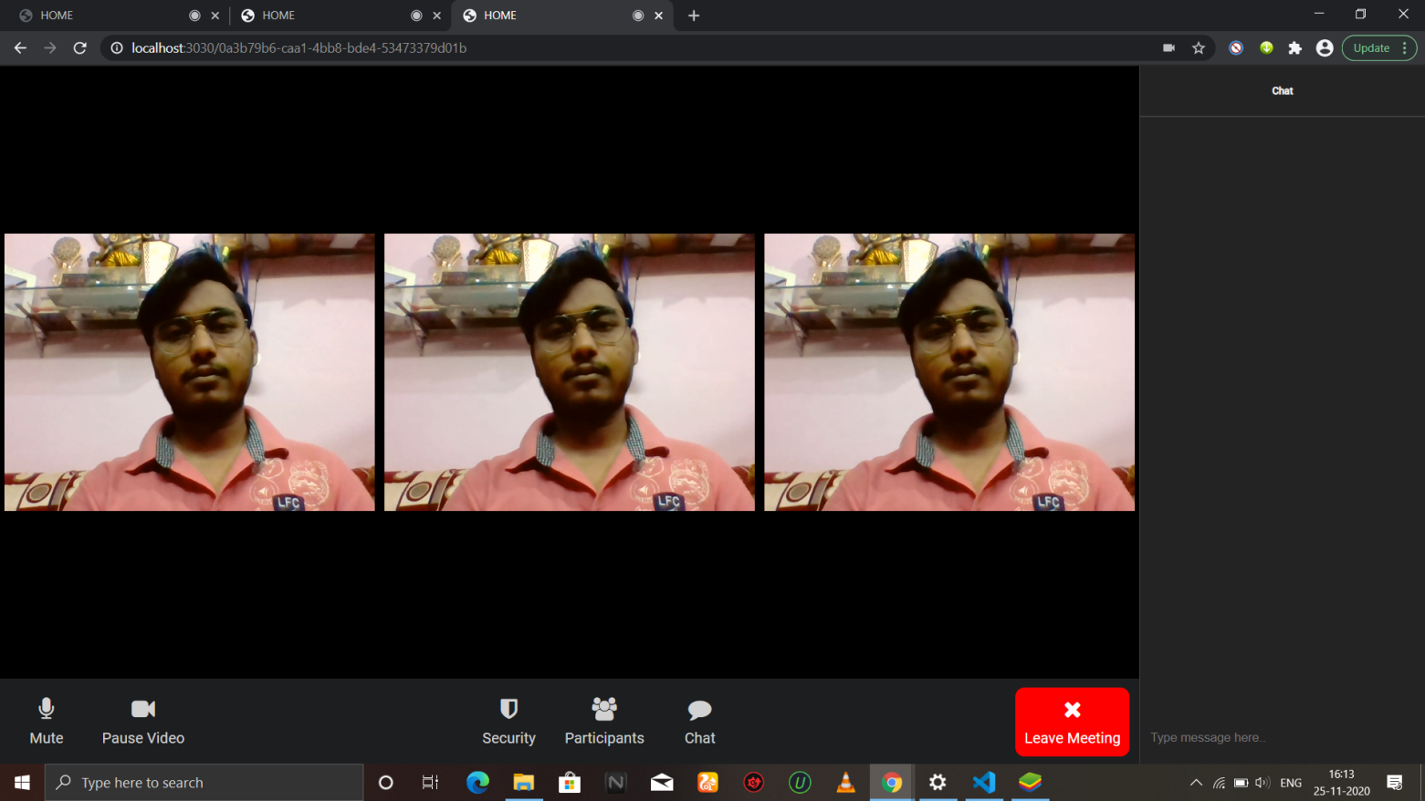

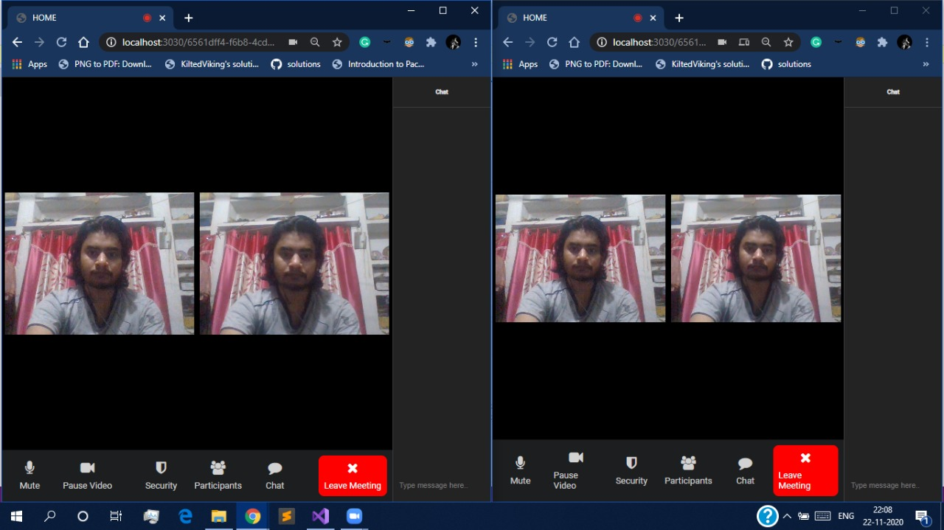

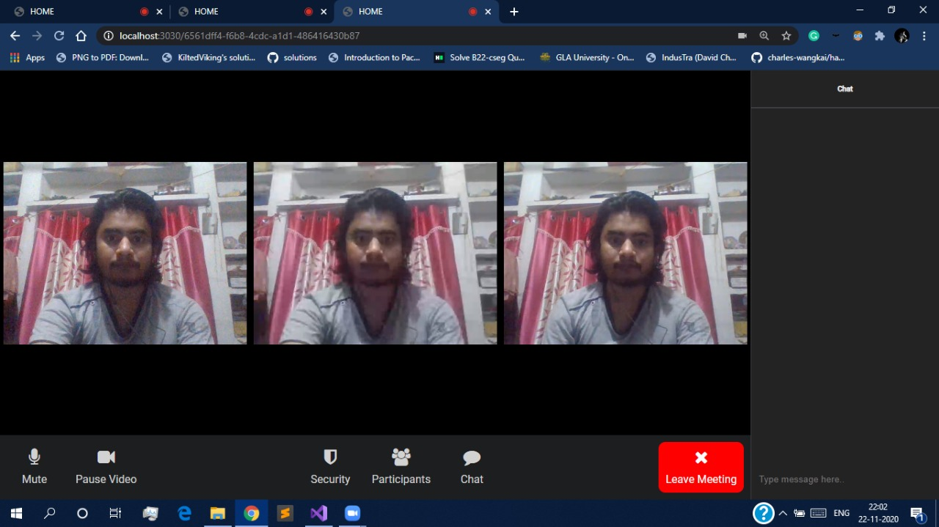

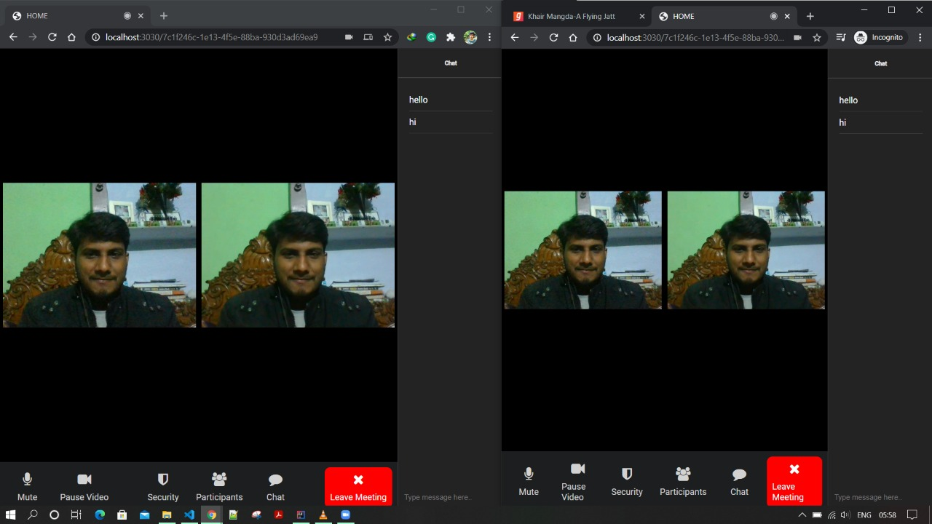

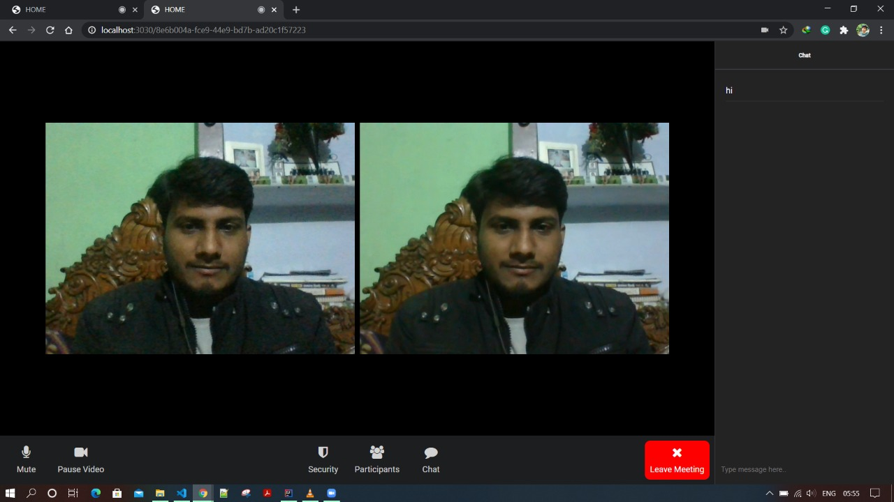

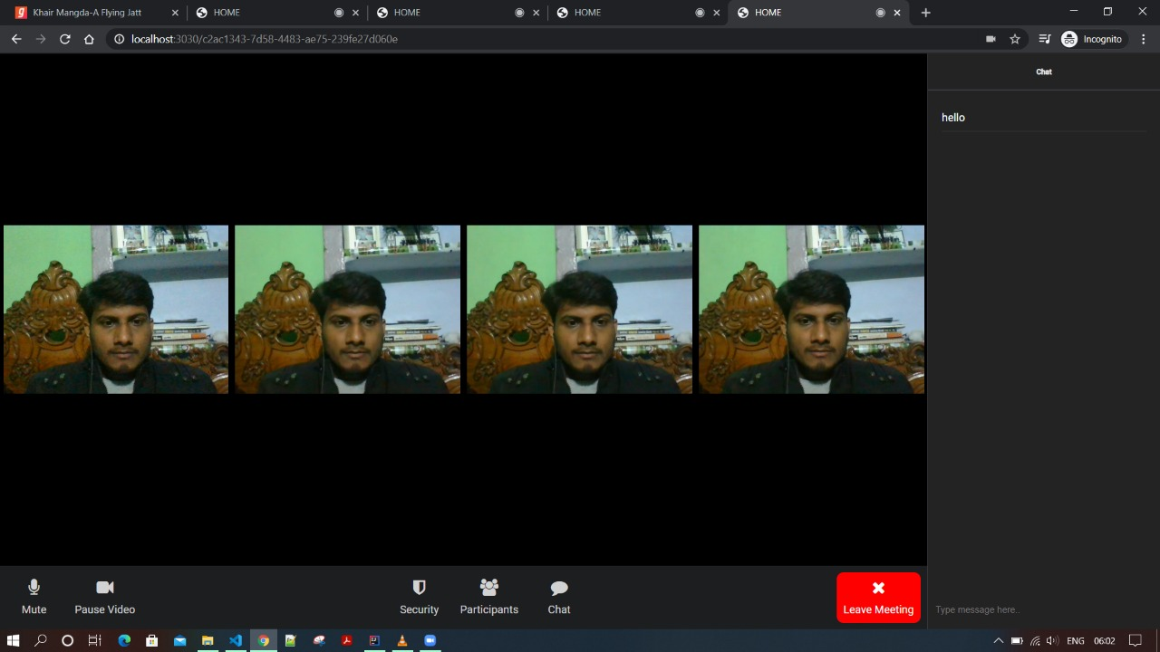

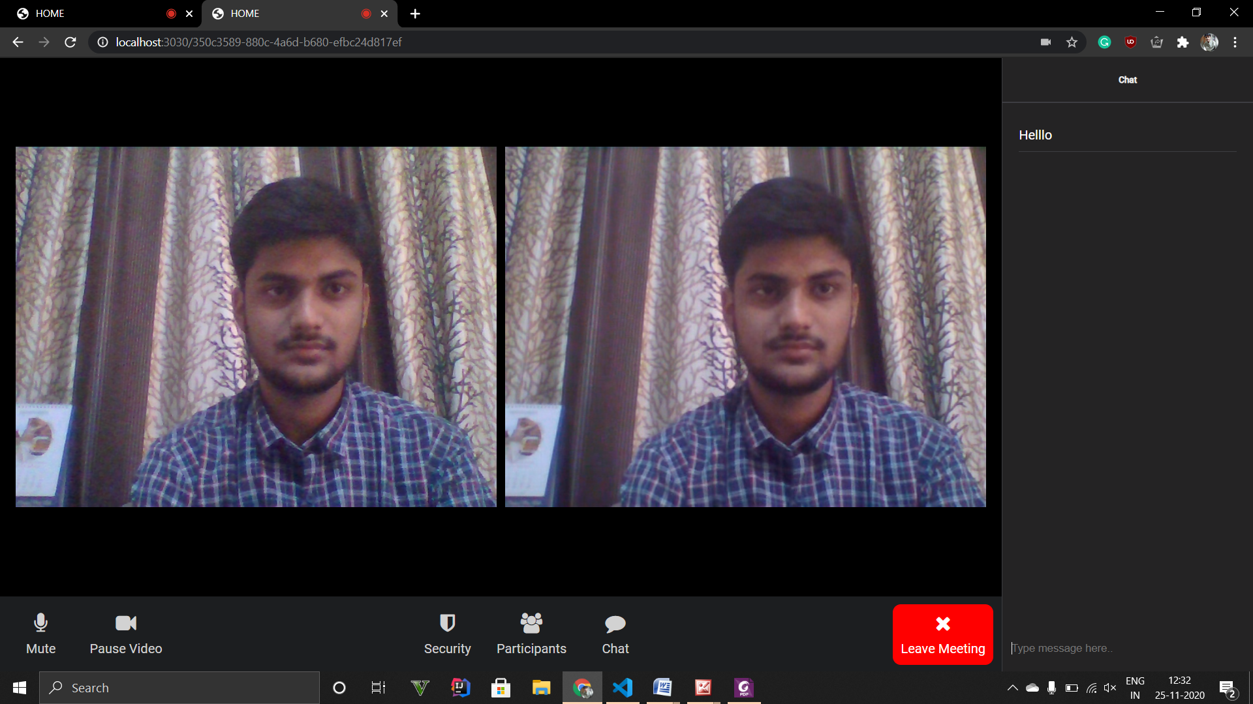

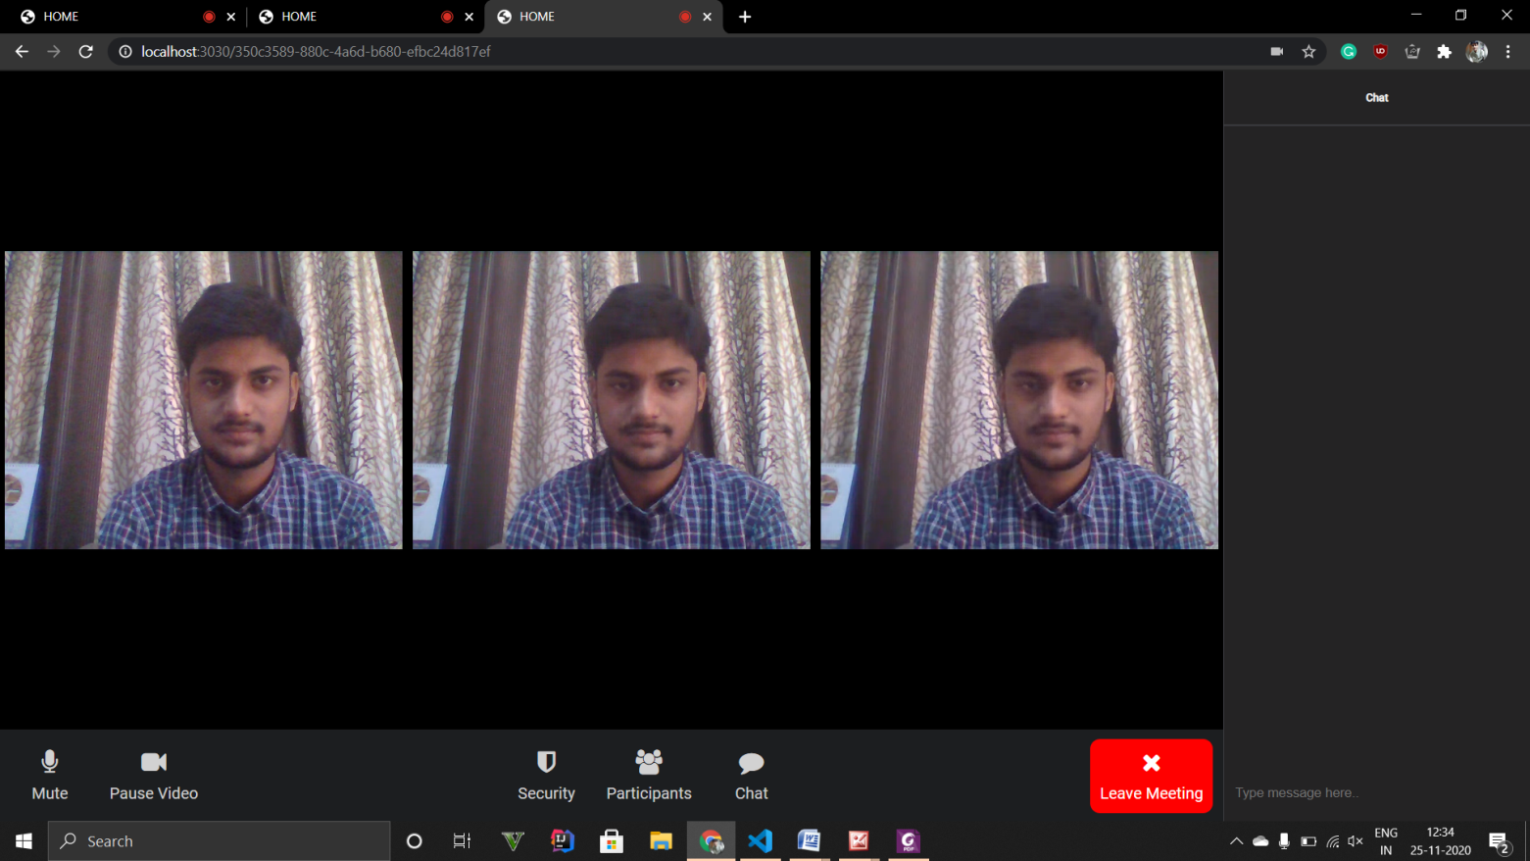

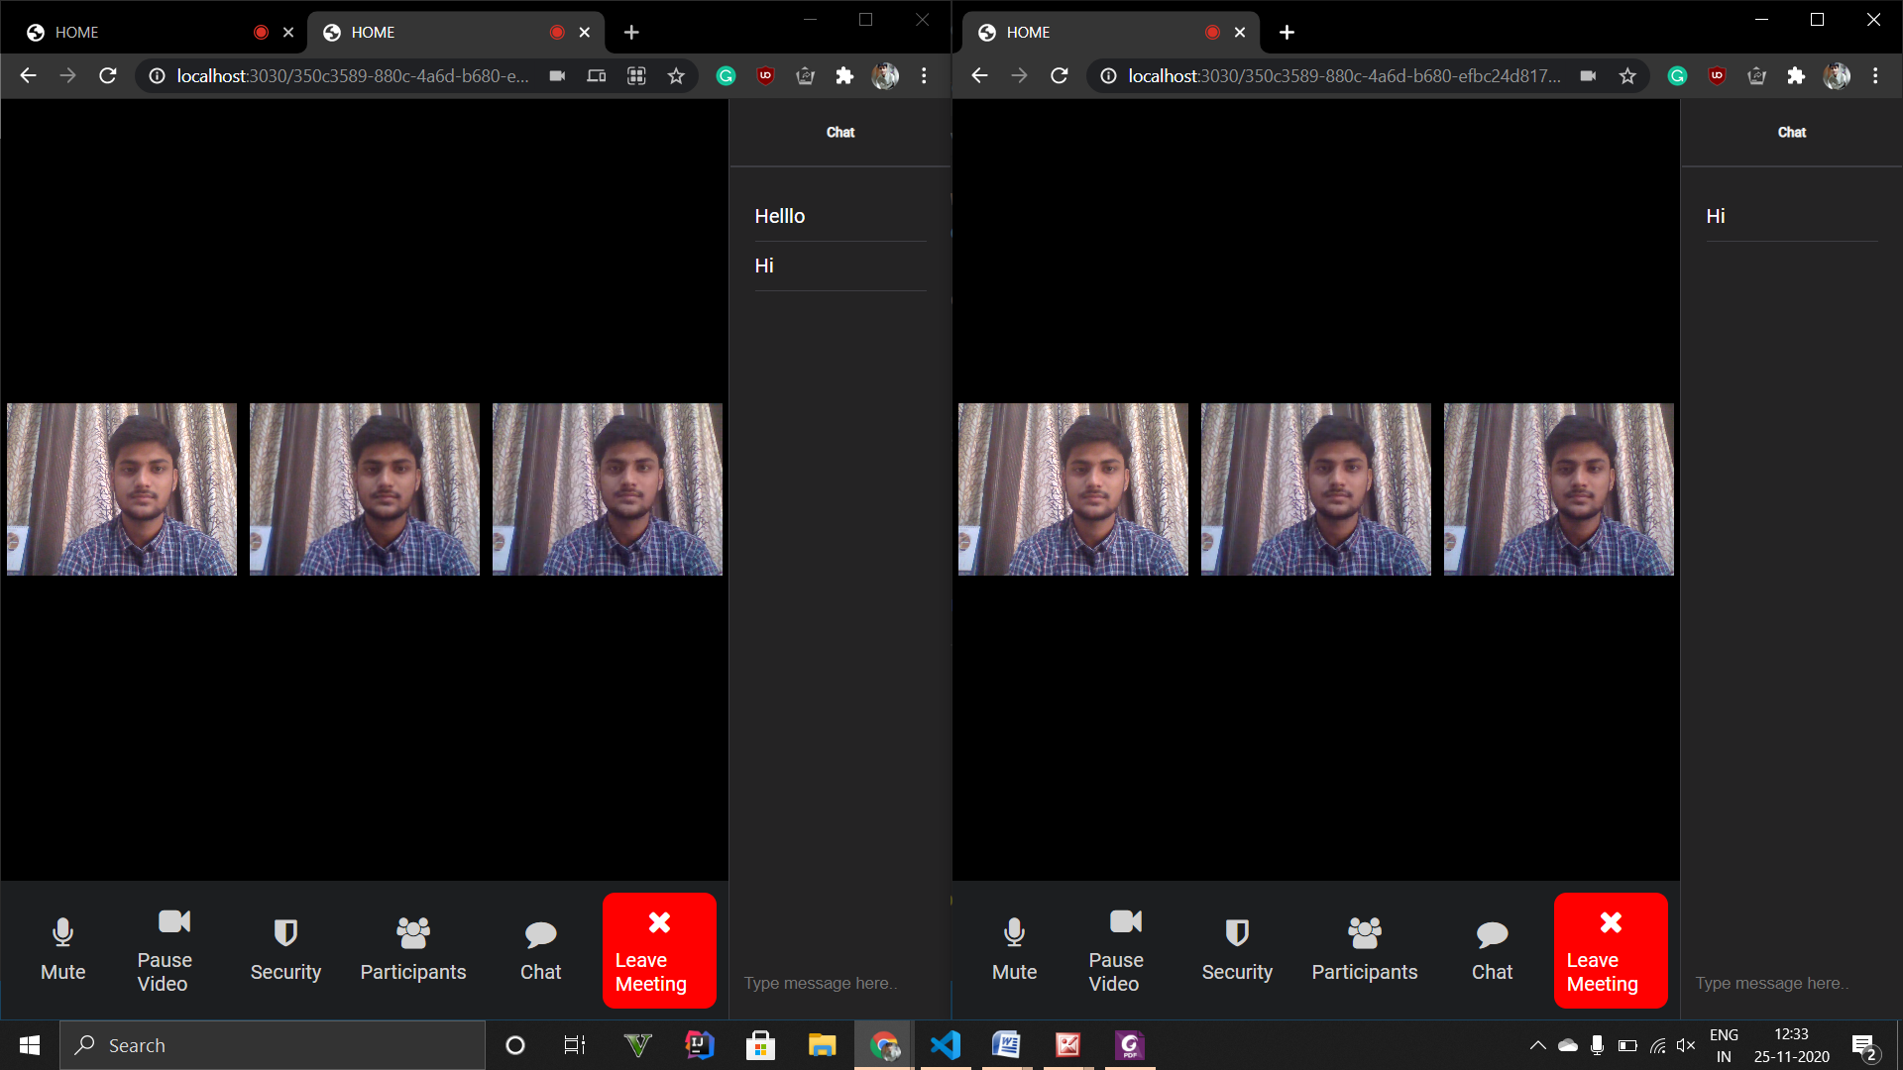

**7.Future Scope:**

1. Since this project works on a local server, in future we can deploy it globally so different users from any part of the world can join the room.
2. We can add Database in the application which enable us to introduce features like Unique ID, Signup, Profile Photo Update, Sharing Screen or Media and Document Share Etc.

**References:**

* <https://nodejs.org/en/>
* <https://socket.io/>
* <https://socket.io/>
* <https://youtu.be/JnvKXcSI7yk>
* [**https://www.geeksforgeeks.org/**](https://www.geeksforgeeks.org/)
* **Faculty Guideline:**
  + - **Ms. Harvinder Kaur**